Client Name:
Patricia Terrell
Client Address:
5468 Koppe Bridge Rd, College Station, TX 77845
Phone Number:
979-402-5226

Distance from the Church:
14.8 miles – 22 minutes

Description of the work:
The “infinite” project – There seems to be an unlimited amount of work we can do here
Demo and build 24ft ramp
Level front deck? As much as possible
12x24 deck, help support, demo some, and repair/redeck

Bring a weed Wacker, a jack might be helpful
Client may mention their brother who lives on property, we have not planned on doing work for them because of no contact

Site Pictures
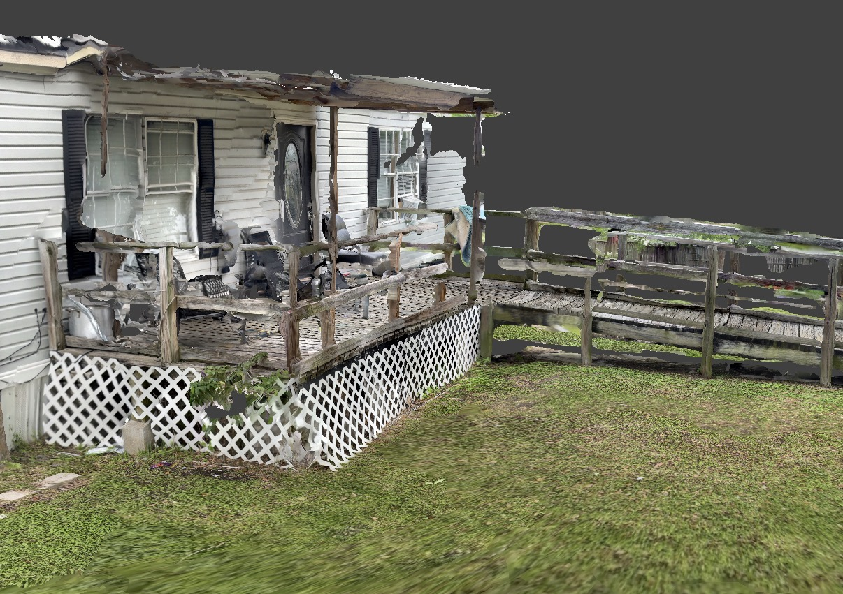
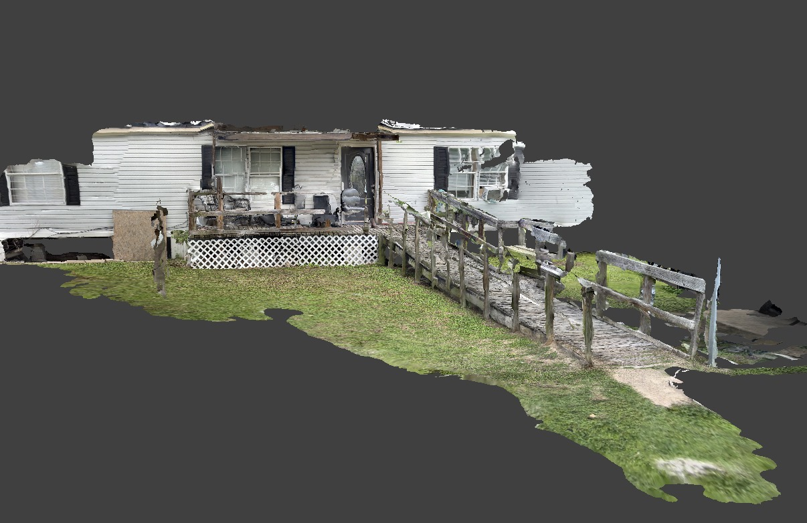
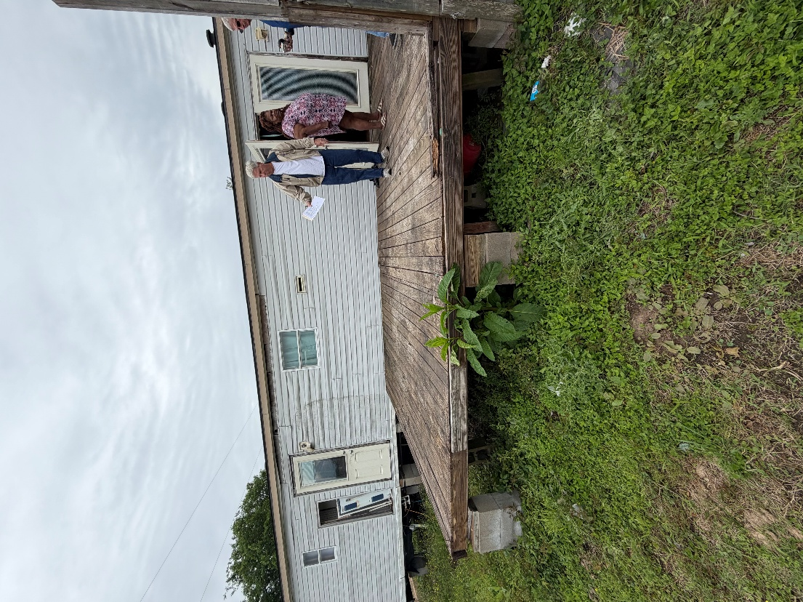
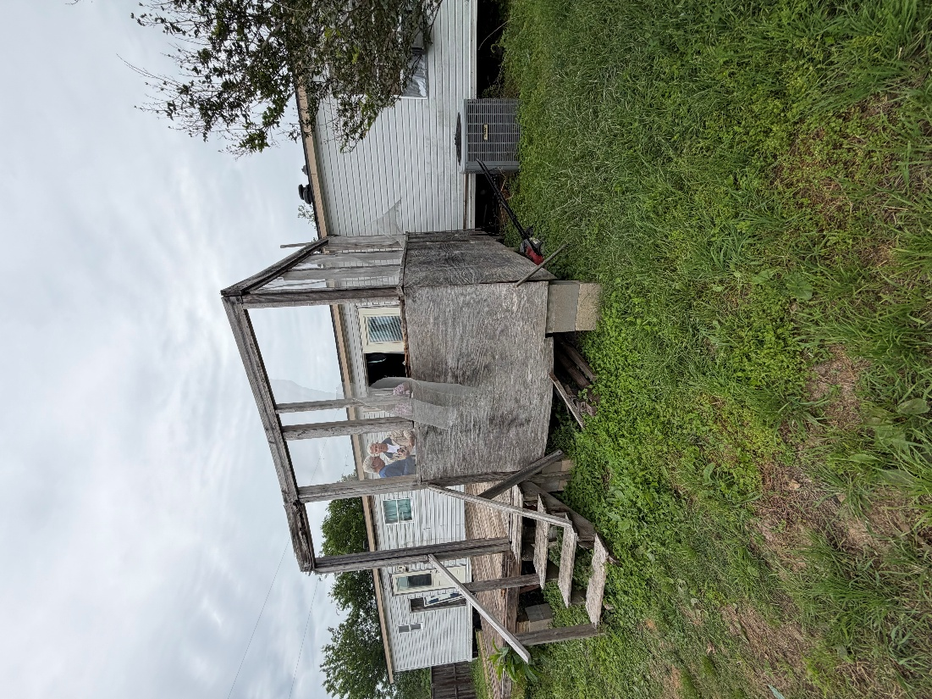
Rendered Project
“Build to site not to plan”


